Technical Paper Writing Competition (FY 2022-2023)

✓A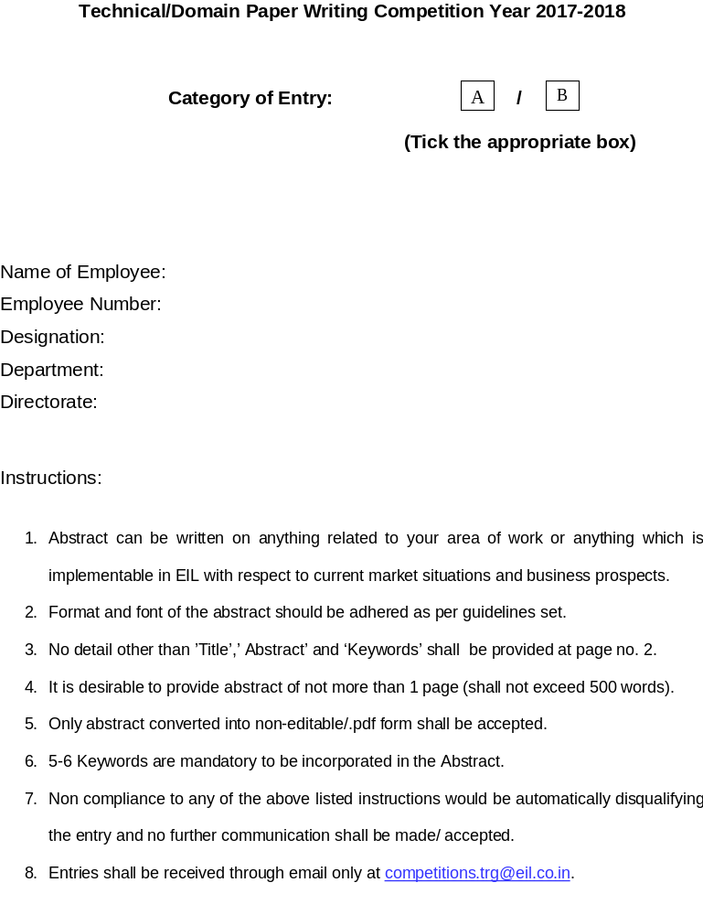
B
Category of Entry (Tick the applicable option):

Details of Full Paper (To be as per the instructions below)
Font Style Used | Font Size Used | No. of Words | Line Spacing | No. of Pages
Arial | 12 | 2257 | 1 | 5

Name of Employee: Sandeep Balivada
Employee Number: D350
Designation: Engineer
Department: Information Technology Services (ITS)
Directorate: Technology
Location: Engineers India Bhawan (HO – New Delhi)

Real Time Temperature and Humidity monitoring inside the Data Center using Internet of Things (IoT)

Abstract:

The advancement in Information Technology and communication techniques led to the development of a new technology called Internet of Things. It is also shortly known as IoT. IoT is basically a network of physical objects that are embedded with sensors, processors, electronics and networks. These physical objects collect and exchange data between each other and fulfill the programmed tasks. Among the various diverse type of applications that can be done using Internet of Things (IoT), real time monitoring and reporting is one of the most important ones. Automation of this activity helps in eliminating all the anomalies that may happen within the time lapse of manual risk identification and reporting to the concerned authority. The idea of this research is to propose and setup an automation system which actively monitors both the temperature and humidity values inside the datacenter using different thermal and humidity sensors. It will also have the ability to immediately send an alert message directly on mobile to the concerned authorities without any delay.

With the advancement of technology in various fields and by the usage of sensors for the required purposes, the possibility of gathering vast amount of data in unimaginable scales has become very feasible. Processing this data to make the calculations and observations more accurate has also become very easy. The usage of new generational neural networks and algorithms helps in training the machines with proper data and letting them predict the next outcome correctly paved the way for Machine Learning. In the context of this research, training the machines with data collected can be left for the future scope as the main motto is to send alert messages immediately without any delay. The approach towards the implementation will be done by using Arduino UNO starter kit, DHT 11 sensor and most importantly SIM 900 GSM shield. Arduino UNO is basically a low cost, flexible, and easy to use programmable open - source micro controller board consisting of various pins dedicated for distinct tasks. Hence, by using these components and programming them in such a way that the micro controller sends an alert text immediately whenever the sensor senses the temperature or humidity values greater or smaller than the pre-defined acceptable ranges mark the successful completion and achievement of this research. Various references used and the documentation of challenges faced during the approach and implementation of the project will be done in this research paper.

Keywords:

Internet of Things, Automation, sensors, alert messages, neural networks, algorithms

Introduction:

Data Center plays an important role in the functioning of an organization. All the other functions of the organization may get halted if the data center stops working. Any minor impact on the proper functioning of the data center will definitely have a huge impact on the entire productivity of the organization. Hence the temperature and humidity variations within the data center will have a serious burden all over. This research paper focuses on proposing an IoT based real time system that effectively monitors the variation in temperature and humidity using sensors, microcontroller, SIM 900 GSM shield and IoT based technologies. Using Internet of Things (IOT) devices, we can control any electronic equipment in homes, industries and other locations. Moreover, the data can be read from any sensor and the collected data can be analyzed graphically from anywhere in the world. Here, we can read temperature and humidity data from DHT11 sensor and send the alerts accordingly if there is any deviation in the required values. This makes the data center highly reliable as this system serves as a backup for the currently used traditional manual monitoring system. Related studies and design methodologies will be discussed along with the results and future scope in this detailed research paper. System flow chart is also included for easy understanding of the proposed real time temperature and humidity monitoring system.

Related Work:

The monitoring framework developed and described in the research paper “IoT based temperature and humidity monitoring framework [1]” touches the concepts of real time monitoring inside specific locations. This paper mainly concentrated on the lockdown situations during Covid 19 peak waves. Raspberry PI can also be used instead of Arduino UNO as described in "IoT based temperature and humidity controlling using Arduino and raspberry Pi [2]". Similar implementation of IOT devices for monitoring in agricultural sector has been discussed in the research papers “IoT based smart agriculture” [3] and "IoT based monitoring system in smart agriculture" [5] on smart agriculture. Real time monitoring has also been implemented in other sectors like industrial sector in "IoT based intelligent industry monitoring system." [6] and health sector in "IoT-Based Healthcare Monitoring System: Bedsores Prevention." [10] and "An IoT based real-time data-centric monitoring system for vaccine cold chain." [11]. IOT tools are also used in environment protection as discussed in "Review on-IoT based environment monitoring system." [8] and "QoS enabled IoT based low cost air quality monitoring system with power consumption optimization." [9]. The implementation techniques used in "IOT based integrated home security and monitoring system" [4] and "Server room temperature & humidity monitoring based on Internet of Thing (IoT)" [7] are used as a reference for understanding and designing the customized real time temperature and humidity monitoring system for EIL’s data center. All the specified related works on the implementation of IOT devices for real time monitoring helped in analyzing the real word scenarios and operational challenges during the development.

Design Methodology:

The list of all required items to implement the proposed system are mentioned as below:
- Arduino UNO
- SIM 900 GSM shield
- Arduino IDE
- 5V 2A Power Adaptor
- SIM Card
- DHT11 Sensor
- 10 k Ohm resistor
- Breadboard
- Jumper Wires

Arduino UNO:

Arduino UNO is a low cost, flexible and easy to use programmable open source microcontroller board that can be integrated into a variety of IOT devices. It is the main brain of the proposed real time temperature and humidity monitoring system. It is similar to a light weight processing unit like CPU with all the necessary resources in limited quantities. It consists of different pins which serve different dedicated purposes. In the context of this research paper, we will be using a complete Arduino UNO user kit which consists of the DHT sensor, bread board and jumper wires along with the Arduino controller.

SIM 900 GSM shield:

The SIM 900 is a common shield for GSM communications on Arduino UNO. The term GSM is the short form for Global System for Mobile Communications and is the global standard for mobile communications. The SIM 900 GSM shield is particularly useful as it allows to send and receive SMS, phone calls and to connect over the internet.

Arduino IDE:

The Aurdino IDE is an open - source Integrated Development Environment Software for Arduino which makes it easy to write code and upload it to the board. This software can be used with any Arduino board. The boards can be programmed with all the requirements by simply righting the code in Arduino IDE and uploading it onto them.

5V 2A Power Adaptor:
Power Adaptor is required to power up the shield. It is advisable to use a 5V power supply that can provide 2A for the proposed real time monitoring system. It can also be powered with 9V 1A, or 12V 1A adaptors.

SIM Card:

A 2G sim card is required to send and receive the text messages. It is always recommended to use a prepaid plan or a plan with unlimited SMS for testing purposes. The pin lock on the SIM card has to be turned off first by connecting to a mobile phone before placing it in the SIM 900 GSM shield.

DHT11 Sensor:

The DHT11 is a commonly used Temperature and humidity sensor that comes with a dedicated NTC to measure temperature and an 8-bit microcontroller to output the values of temperature and humidity as serial data. The sensor can measure temperature from 0°C to 50°C and humidity from 20% to 90% with an accuracy of ±1°C and ±1%. So, this sensor is the right sensor for the proposed system as the temperatures are never going to go below 0°C or above 50°C inside the data center.

10 k Ohm resistor:

For an input pin, the 10K Ohm resistor serves as a pull-up resistor. For example, on Arduino, we can use a 10K Ohm resistor so that when the button is pressed, it pulls the input pin high with 5V, triggering an action in the code. This trigger will help in sending the alert texts to the concerned authorities.

Breadboard:

The breadboard is a white rectangular board with small embedded holes to insert electronic components. This is a simple board for prototyping or building circuits on. It allows to place the components and connections on the board to make the circuits without the requirement of soldering.

Jumper Wires:

Jumper wires are just simple wires that have connector pins on both the ends. This allows them to easily connect any two points without the need of traditional soldering. They play a major role in the circuit creation of prototyping tools, micro controllers and bread boards.
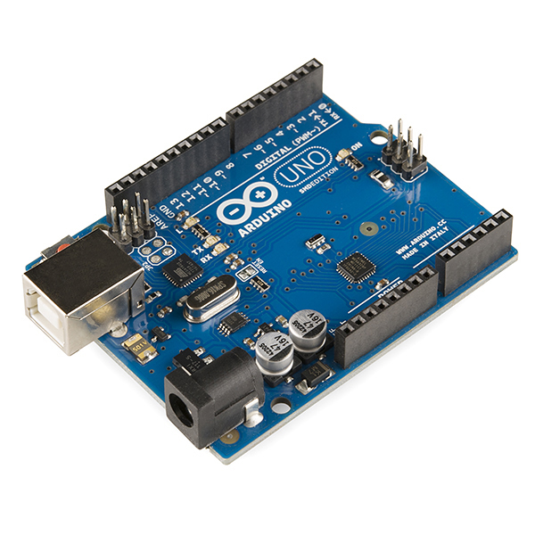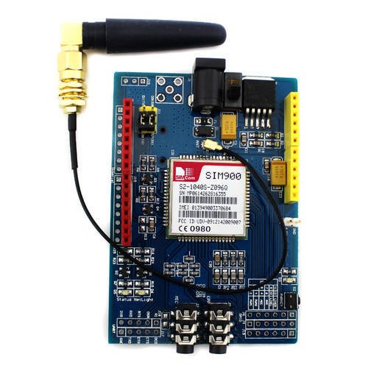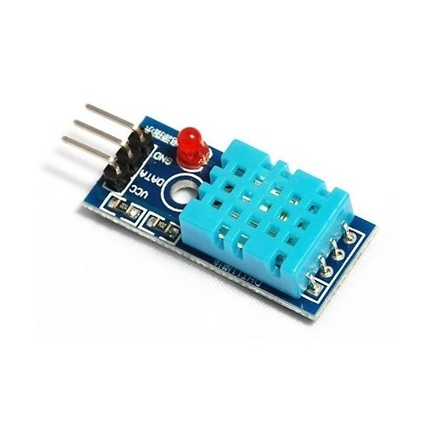

Arduino UNO SIM 900 GSM shield DHT 11 sensor

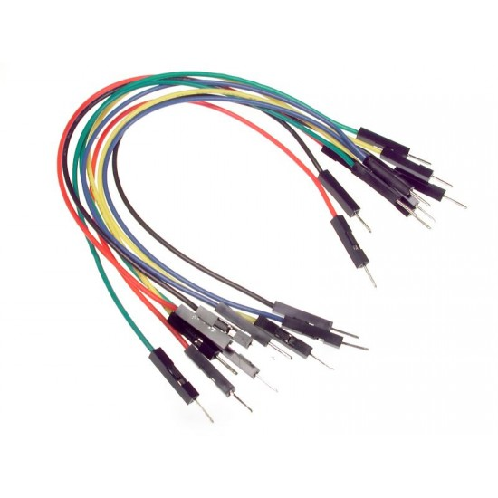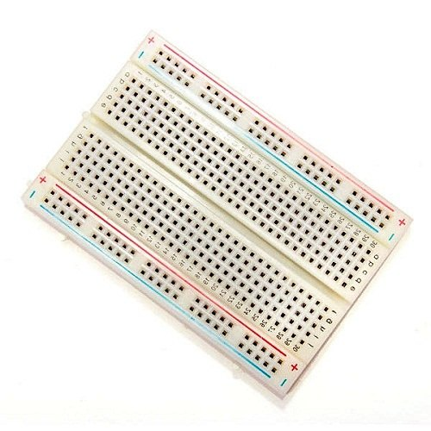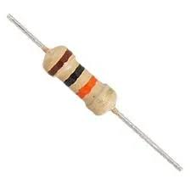

Jumper wires Bread Board 10 kOhm resistor

Implementation:

The 5V 2A power adapter has to be connected to a power source at one end and to the DC power jack of the SIM 900 GSM shield on the other end. The toggle switch beside the DC power jack has to be used to direct the power from external power supply. The 2G SIM card with PIN lock turned off and with unlimited prepaid SMS pack has to be placed in the SIM card holder of the GSM shield.
Then the GSM shield has to be connected to the Arduino UNO and DHT 11 sensor by connecting the Serial communication pins TXD and RXD of the shield with pins 7 and 8 of Arduino by following the manuals. The transmission pin (serial output pin) TXD has to be connected to pin 7 and the receiver pin (serial input pin) RXD has to be connected with pin 8. 10 k ohm resistor has to be placed in the connection of DHT 11 sensor with the arduino. Jumper wires are to be used for making all the connections. Bread board can be used if necessary.
After all the connections and basic setup is done, the coding has to be done in Arduino IDE. DHT library and Adafruit_sensor library are required to be imported in the headers. The completed code can be uploaded on to the arduino board so that the setup gets completely programmed to detect the temperature and humidity and send an SMS to the specified number. The alerts can also be sent to multiple people simultaneously based on the risk level like the primary data center incharge, maintenance engineer of datacenter, support engineer present in the data center, head of the security department, DGM and GM of infrastructure, PA of HoD ITS, PA of ED(T), PA of D(T) and PA of CMD (EIL) for immediate actions and information in case of emergencies.

System Flowchart:

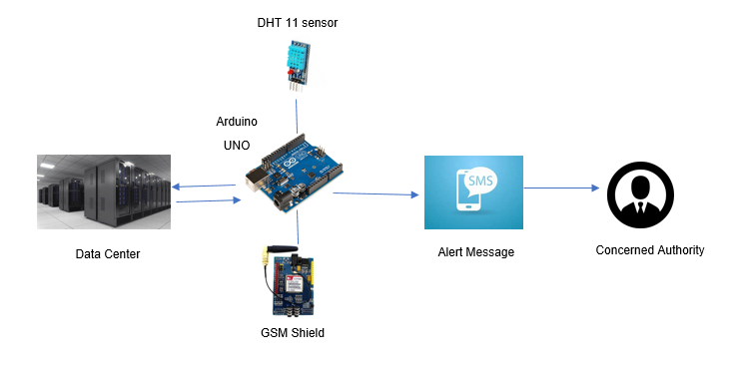
Flowchart of Real time temperature and humidity monitoring system

Results:
It has been observed that the alerts are getting generated immediately without any delay. Whenever the IOT device is prompted with a request to provide the current status of temperature and humidity inside the datacenter, an instant text message is received on the requestor’s mobile device with the status. Hence the real time temperature and humidity monitoring inside the data center has been made very much feasible by using IOT devices like Arduino UNO, SIM 900 GSM shield and DHT 11 sensor. The total cost of implementation and maintenance is also too low compared to the traditional system of monitoring.

Conclusions:

The automated monitoring system proposed in this research paper is highly accurate in alerting the authorities. As no physical presence of the individual at the datacenter is required for this system, it is very much effective in overcoming all the discussed issues. The graphical representation of the collected data at regular intervals is also useful in identifying the behavior of temperature and humidity within the data center at different intervals. If there is any unusual behavior or phenomenon, necessary precautions can be taken accordingly to mitigate the risks based on the observations. As instant notifications are also being sent to the higher authorities and security heads along with the immediate attending authority, there will be complete transparency in the information.

Future Scope:

As a vast amount of data is being collected regularly at different intervals of time using the real time temperature and humidity monitoring system, this data can serve as a dataset to train a neural network with different machine learning algorithms. The trained machine can further be tested using validation data set which can also be taken from the same proposed system. Once the prediction levels in the confusion matrix crosses 85% or 0.85, the trained machine learning neural network can be used to accurately predict the expected temperature and humidity within the datacenter at different scenarios. This can also be in turn used as a simulation tool to test the reliability of the currently used cooling and maintenance systems. Along with this, the data collected can be stored in cloud storage systems to overcome the limitations of storage of huge data. This moreover helps in faster retrieval of information from any geographical location during future references. Addition of other sensors to the same unit along with temperature and humidity sensor, will help in collecting more diversified data. Concepts of block chain can also be used in the future scope so that no tampering or mis use of data can be done by any individual. Apart from the maintenance scope, solar power can also be used to replace the existing external power supply in the functional scope of the system. This will help in reducing the burden on the environment.

References:

- Ab Rahman, Rafizah, Ummi Raba'ah Hashim, and Sabrina Ahmad. "IoT based temperature and humidity monitoring framework." Bulletin of Electrical Engineering and Informatics 9, no. 1 (2020): 229-237.

- Barik, Lalbihari. "IoT based temperature and humidity controlling using Arduino and raspberry Pi." International Journal of Advanced Computer Science and Applications 10, no. 9 (2019).

- Gondchawar, Nikesh, and R. S. Kawitkar. "IoT based smart agriculture." International Journal of advanced research in Computer and Communication Engineering 5, no. 6 (2016): 838-842.

- Adriano, Davin Bagas, and Wahyu Apsari Ciptoning Budi. "Iot-based integrated home security and monitoring system." In Journal of physics: conference series, vol. 1140, no. 1, p. 012006. IOP Publishing, 2018.

- Prathibha, S. R., Anupama Hongal, and M. P. Jyothi. "IoT based monitoring system in smart agriculture." In 2017 international conference on recent advances in electronics and communication technology (ICRAECT), pp. 81-84. IEEE, 2017.

- Kavitha, B. C., and R. Vallikannu. "IoT based intelligent industry monitoring system." In 2019 6th International Conference on Signal Processing and Integrated Networks (SPIN), pp. 63-65. IEEE, 2019.

- Utomo, Moechammad Alvan Prastoyo, Abdul Aziz, and Bambang Harjito. "Server room temperature & humidity monitoring based on Internet of Thing (IoT)." In Journal of Physics: Conference Series, vol. 1306, no. 1, p. 012030. IOP Publishing, 2019.

- Shinde, Snehal R., A. H. Karode, and S. R. Suralkar. "Review on-IoT based environment monitoring system." International Journal of Electronics and Communication Engineering and Technology 8, no. 2 (2017): 103-108.

- Barot, Virendra, Viral Kapadia, and Sharnil Pandya. "QoS enabled IoT based low cost air quality monitoring system with power consumption optimization." Cybernetics and Information Technologies 20, no. 2 (2020): 122-140.

- Abdelmoghith, Aya, Rewan Shaaban, Zeinab Alsheghri, and Loay Ismail. "IoT-Based Healthcare Monitoring System: Bedsores Prevention." In 2020 Fourth World Conference on Smart Trends in Systems, Security and Sustainability (WorldS4), pp. 64-69. IEEE, 2020.

- Hasanat, Raisa Tahseen, MD Arifur Rahman, Nafees Mansoor, Nabeel Mohammed, Mohammad Shahriar Rahman, and Mirza Rasheduzzaman. "An IoT based real-time data-centric monitoring system for vaccine cold chain." In 2020 IEEE East-West Design & Test Symposium (EWDTS), pp. 1-5. IEEE, 2020.

